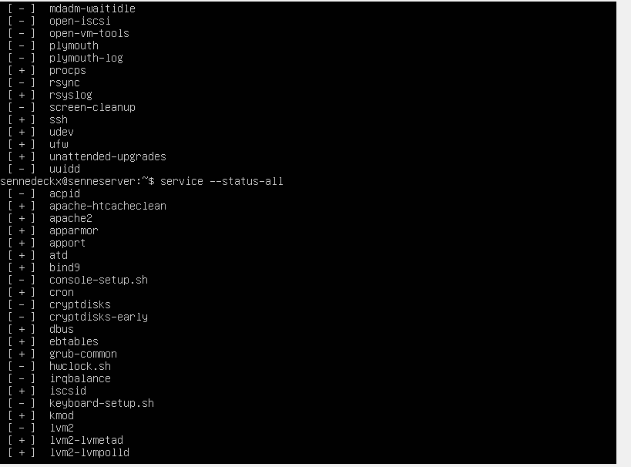

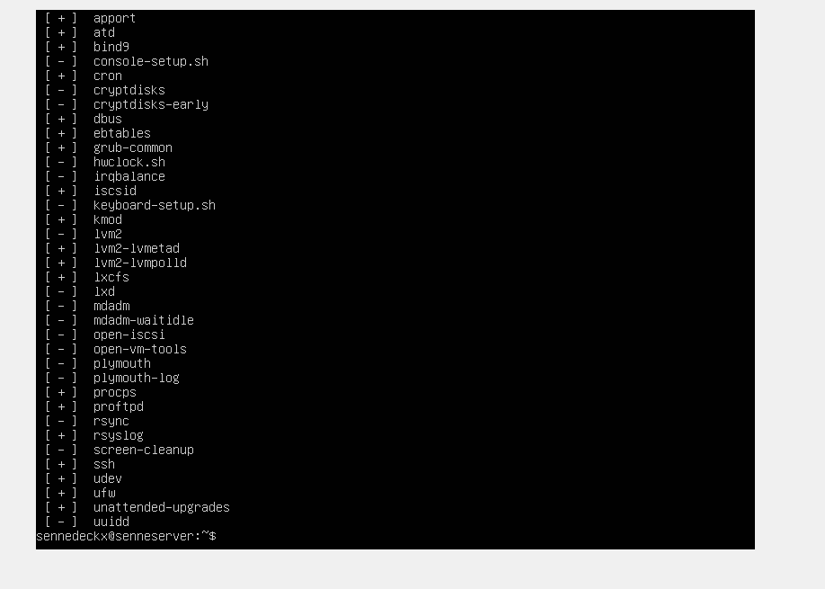

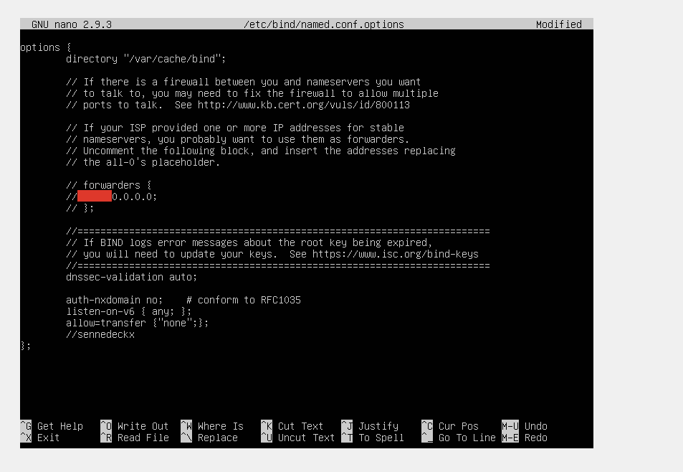

-P INPUT ACCEPT

-P FORWARD ACCEPT

-P OUTPUT ACCEPT

-A INPUT -p icmp -m icmp --icmp-type 8 -m limit --limit 5/min -j ACCEPT

-A INPUT -p icmp -j DROP  
(prevent flooding)

-A INPUT -m state --state ESTABLISHED,RELATED -j ACCEPT

-A OUTPUT -p icmp -m icmp --icmp-type 0 -j ACCEPT

-A OUTPUT -m state --state ESTABLISHED,RELATED -j ACCEPT

(allow only outgoing connections except fort he returning one 🡺 RELATED - The connection is new, but is related to another connection already permitted. ESTABLISHED - The connection is already established.)

-A OUTPUT -p tcp -m tcp --dport 80 -m state --state NEW -j ACCEPT  
(To allow incoming TCP traffic for HTTP on port 80)

-A OUTPUT -p tcp -m tcp --dport 53 -m state --state NEW -j ACCEPT

-A OUTPUT -p udp -m udp --dport 53 -m state --state NEW -j ACCEPT  
(enable dns connection to our firewall hosts,without source/Dest networks. Served on both udp and tcp, so its seperated on two lines.)